PHASE 4 – Other Issue Classification
Activity : 4 Projector Issue Classification.
- Now Select the Else If Condition.
- Condition label : SD is Projector or Hardware.
- Condition : Short description Contains Prajector.
- Then Click the Done button.
- Now Action is an Update record.
- Set Category=Hardware 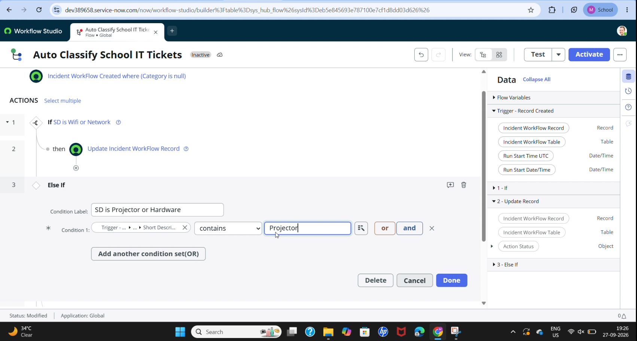
- Set Subcategory = Projector.
- Then Click the Done button.

Activity : 5 Password Issue Classification.
- Now again select Else If condition.
- Condition label : SD is Forgot password.
- Condition : Short description contains Forgot password.
- Then Click the Done button.
- Now Action is an Update Record.
- Set Category = Access.
- Set Subcategory = Forgot Password.
- Then Click the Done button.

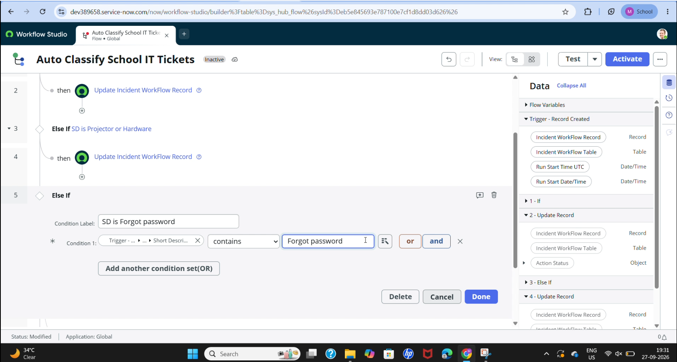

Activity : 6 Slow Computer Classification.
- Now Again Click the Else If Condition.
- Condition label : SD is Performance.
- Condition : Short description contains Slow Computer.
- Then Click the Done button.
- Now Action is an Update Record.
- Set Category = Performance.
- Set Subcategory = Slow computer.
- Then Click the Done button.

